1.

SELECT COUNT(studentID) AS System_Analysis_Database_Design

FROM course_mapping WHERE courseID = 2;

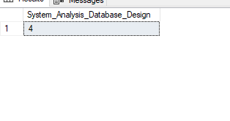

2.

SELECT faculty.first_name,faculty.last_name

FROM faculty JOIN course_mapping_faculty

ON course_mapping_faculty.facultyID = faculty.facultyID

JOIN course ON course.courseID = course_mapping_faculty.courseID

WHERE course_mapping_faculty.courseID = 2;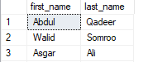

3.

SELECT AVG(marks) AS Average_Grade FROM grade WHERE courseID = 2;

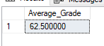

4.

SELECT course.course_name, days.day_name

FROM course JOIN schedule ON course.courseID = schedule.courseID

JOIN days ON days.dayID = schedule.dayID

WHERE schedule.dayID = 1;

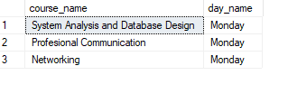

5.

SELECT student.studentID,student.first_name,grade.marks

FROM student INNER JOIN grade ON student.studentID = grade.studentID

WHERE grade.marks >= 70;

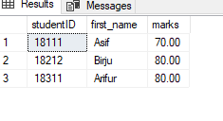

6.

SELECT student.student_type,student.first_name,course.course_name,grade.marks

FROM student JOIN grade ON grade.studentID = student.studentID

JOIN course ON course.courseID = grade.courseID

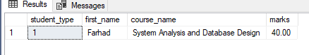WHERE grade.marks < 50;

7.

SELECT faculty.first_name,faculty.last_name,course.course_name,days.day_name

FROM faculty JOIN schedule ON faculty.facultyID = schedule.facultyID

JOIN course ON schedule.courseID = course.courseID

JOIN days ON schedule.dayID = days.dayID

JOIN course_mapping ON course_mapping.courseID = course.courseID

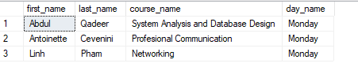 WHERE course_mapping.studentID = 18111;

8. Show the ID of the student whose payment is due

SELECT student.studentID FROM student

JOIN payment ON payment.studentID = student.studentID

WHERE payment_status = 'False';

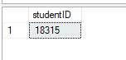

9. Show the highest to lowest grade in a particular unit

SELECT student.studentID,student.first_name,grade.marks

FROM student JOIN grade ON grade.studentID = student.studentID

WHERE grade.courseID = 2

ORDER BY grade.marks DESC;

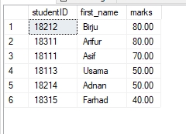

10. Show maximum course fee of the program

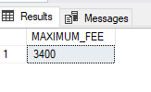SELECT MAX(course_fee) AS MAXIMUM_FEE FROM course;